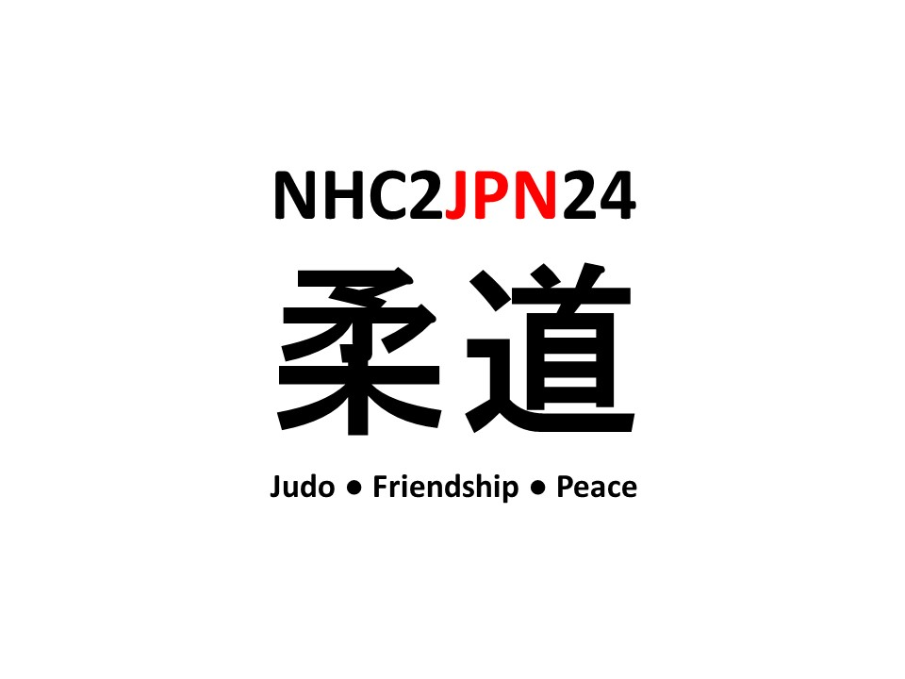****

**British Judo Northern Home Counties Area**

**Student Development Course**

**Tokyo, Japan**

**25th May – 2nd June 2024**

# NHC Student Development Course 2024

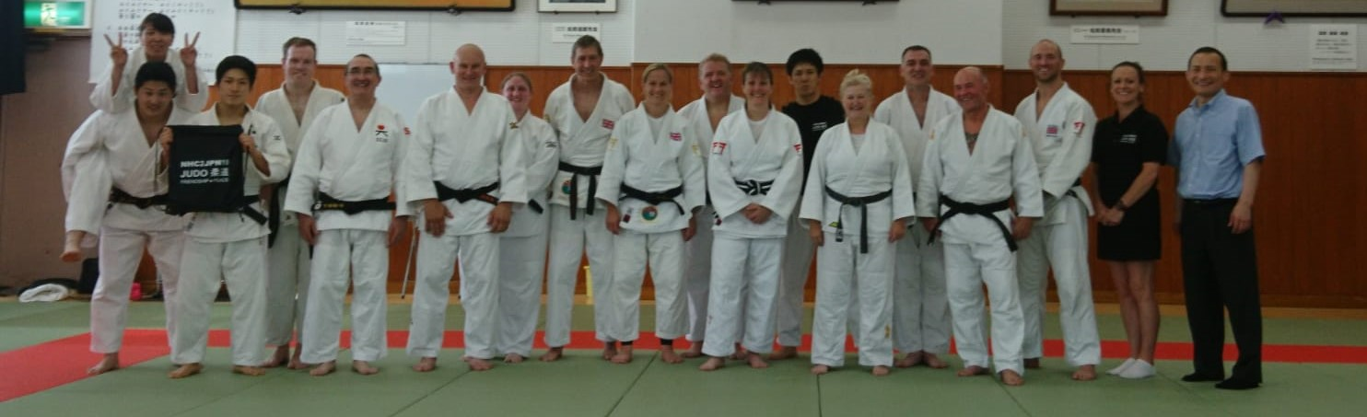

**Summary**

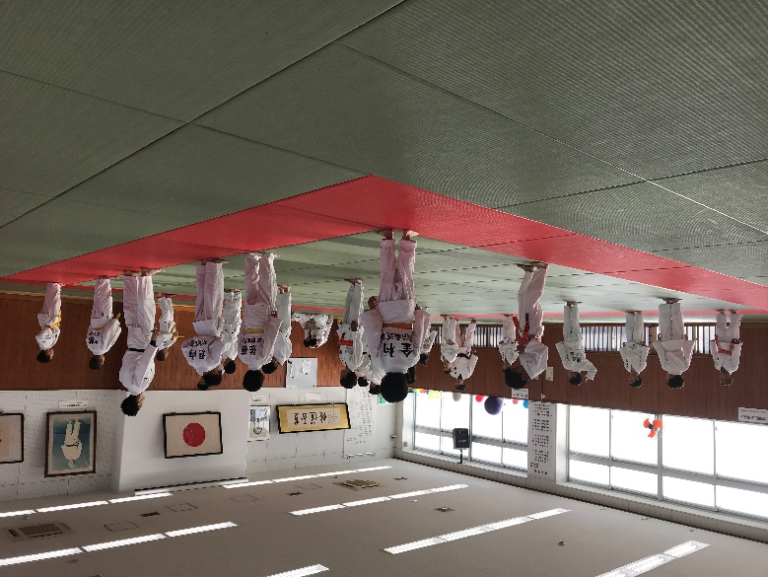To continue the long-term benefit of the delivery of judo in the NHC, through a structured student development programme in Japan. Deeping intercultural understanding between NHC Judoka and Japanese Judoka. Providing students with an educational experience in judo and Japanese culture. Observing and practicing “Judo, Friendship, Peace”

**When:** 25th May – 2nd June 2024

**Where:** Matsumae Judo Juku, Musashino, Tokyo, Japan

Matsumae Judo Juku was founded by former IJF President, Dr Shigeyoshi Matsumae. It is managed by Bosei Gakujuku, part of the Tokai University Educational System.

**Leads:** Takahide Haraguchi (Head Instructor at MMJ), Martin Rance and a female coach from the NHC

**Participants:** 8 students from NHC. Equal Male and female Split

**Selection Criteria:** Must hold a valid NHC licence, Area Level Player, First Year Cadet (born 2009), Minimum grade of 10th Mon desirable.

**Accommodation:** Kōdōkan

**Selection:** By application and process by NHC2JPN Selection committee

**Content**

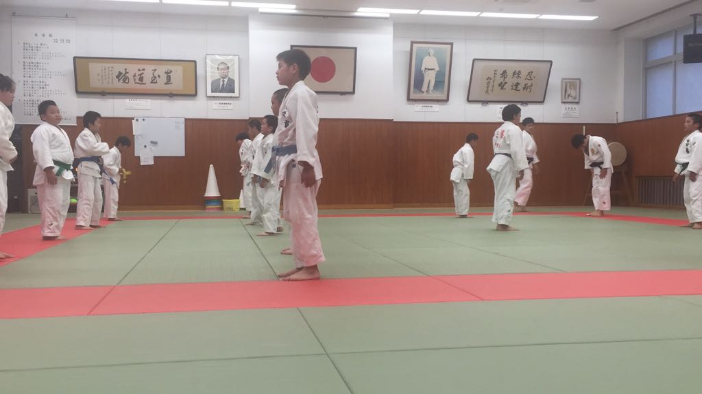A structured development programme to increase understanding of Japanese judo. Training methods, technical matters, culture, and philosophy. Providing a life-changing experience, communicating the values of judo, which cements the young person's relationship with judo for life. This development opportunity will provide leadership opportunities for young people, building their confidence, social skills, and teamwork. The emphasis will be on education through physical participation.

The selection process will seek individuals with an open mind to best benefit from the educational process.

**Cost Structure**

Participants to cover cost of flights. NHC to cover costs whilst in Japan funded by Daiwa Grant Foundation and British Judo Trust.

**Informal enquiries**

Contact Martin Rance, NHC Technical and Coaching Lead via [nhccoaching@gmail.com](mailto:nhccoaching@gmail.com)

To express an interest please complete the form below.

We would be pleased to receive expressions of interest by **Saturday 27th January 2024.**

[**https://docs.google.com/forms/d/e/1FAIpQLSf80GAnRM8_ZQU1tinZRZ_5IG7YdJeTFEjVkmTXXBqpkyW6sQ/viewform?usp=pp_url**](https://docs.google.com/forms/d/e/1FAIpQLSf80GAnRM8_ZQU1tinZRZ_5IG7YdJeTFEjVkmTXXBqpkyW6sQ/viewform?usp=pp_url)